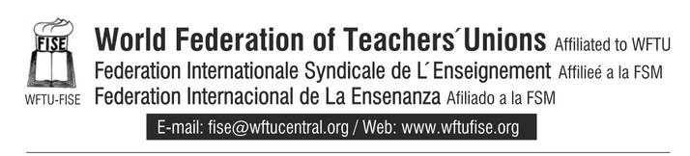

13th June 2013

Mr. Kyriakos Kenevezos
Minister of Education and Culture of Cyprus

Dear Minister,

On behalf of the World Federation of Teachers` Unions (FISE) of the World Federation of Trade Unions (WFTU) expresses its strong disagreement with the decision of the Ministry of Education and Culture of Cyprus to close down the afternoon and evening educational programmes.

The decision of the Ministry to abolish the programmes and proceed to the purchase of services violates the inalienable right of teachers for regulated and permanent employment, as well as the right to conclude collective agreements.

Furthermore, this decision will have severe consequences for the 2,500 teachers since apart from the fact that they are being led to unemployment, at the same time they will loose the right of access to social funds (unemployment benefit, funds subsidizing teacher's holidays, maternity allowance).

At the same time, this is a serious blow to the institution of education as a social asset.

The World Federation of Teachers´ Unions of WFTU unites its voice with the struggling striking teachers of Cyprus, with the Cypriot class-orientated workers movement and calls on you to proceed immediately to meet the demands of the strikers and safeguard their trade union rights.

The Secretariat

